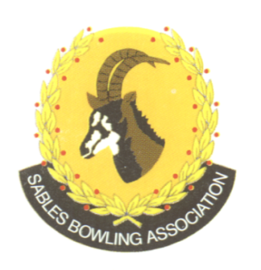
NPC:# 2026/610784/08
CELL NO: 071 688 3088
E-MAIL:
Sablesbowls1@gmail.com
SABLES BOWLING ASSOCIATION

SABLES DISTRICT STRONGER TOGETHER

Club Memo 36/2026 10TH September 2026

SUBJECT: Safeguarding

As discussed at the Sables AGM in August 2026, the attached safeguarding poster must be displayed in several locations throughout every clubhouse. It is suggested that the ablutions plus entry points would be ideal.

Your co-operation in this matter is greatly appreciated.

Regards
Brian Oxley
Sables President

