SABLES BOWLING ASSOCIATION
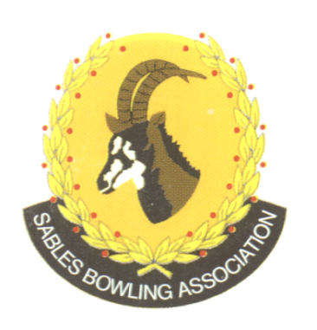
NPC: 2026/610784/08
CELL NO: 071 688 3088
Sablebowls1@gmail.com

1st

Sables District Stronger together

Club Memorandum 32/2026 12th August 2026

SUBJECT: BSA AND SABLES AFFILIATION FEES

Please note that Mike Olwagen has taken over as Sables Treasurer from the 1st July 2026.

Please direct all finance related queries directly to him

083 300 9303 – molwagen@citypower.co.za

Regards

Melana Selby
Sables District Secretary

