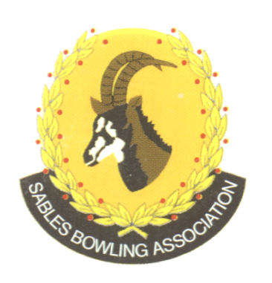
CELL NO: 071 688 3088
E-MAIL:
Sablebowls1@gmail.com

SABLES BOWLING ASSOCIATION

1st

Sables District Stronger together

Club Memo 30/2026
Memorandum
From
SABLES BOWLING ASSOCIATION
31st July 2026

TO: CLUB PRESIDENTS
CLUB SECRETARIES
SUBJECT: Sables Competitions Secretary and Executive Members

The positions for the Sables Competition Secretary as well as Executive Members is still available.

Please can we request nominations from the Clubs before the AGM on the 8th August 2026.

Regards

Brian Oxley
Sables President

