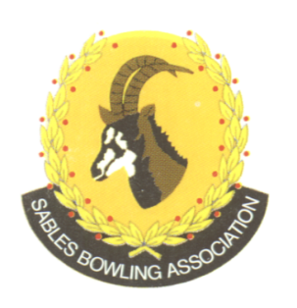
CELL NO: 071 688 3088
E-MAIL:
Sablesbowls1@gmail.com
SABLES BOWLING ASSOCIATION

SABLES DISTRICT STRONGER TOGETHER
Club Memo 29/2026
Memorandum
From
SABLES BOWLING ASSOCIATION
29th July 2026
TO: CLUB PRESIDENTS
CLUB SECRETARIES

SUBJECT: SASCOC Report
Dear All,

Please could you check that all your club details are correct on the BSA Database:

Executive Committee Members
Standing Committees
Club Information Officers
Scholars (check ages)

We need the information to be accurate for a SASCOC Audit Report.

Thanks for your help.

Regards
Melana Selby
Sables District Secretary

