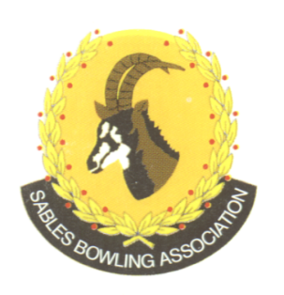
CELL NO: 071 688 3088
E-MAIL:
Sablesbowls1@gmail.com
SABLES BOWLING ASSOCIATION

SABLES DISTRICT STRONGER TOGETHER
Club Memo 25/2026
Memorandum
From
SABLES BOWLING ASSOCIATION
7th July 2026

TO: CLUB PRESIDENTS
CLUB SECRETARIES

SUBJECT: AGM Club Proposals & Motions

Dear All

As you know there will be an AGM on the 8th August 2026 at Krugersdorp Bowling Club at 8:30 for 9:00.

We would like to request that clubs submit proposals & motions by no later than the 20th July 2026.

We will then distribute the final agenda by the 26th July 2026.

Regards

Brian Oxley
Sables President

