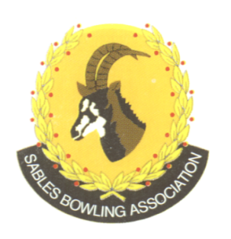
CELL NO: 071 688 3088
E-MAIL:
Sablesbowls1@gmail.com
SABLES BOWLING ASSOCIATION

SABLES DISTRICT STRONGER TOGETHER
Club Memo 24/2026
Memorandum
From
SABLES BOWLING ASSOCIATION
10th July 2026

TO: CLUB PRESIDENTS
CLUB SECRETARIES

SUBJECT: Results of our “Para” (PD/VI) Bowlers – Gauteng Open

We herewith extend out congratulations to

TRACY SMITH - SILVER
Director – Tommy Smith

SALOME MORRIES – BRONZE
Director – Danie Loots

JOHANNES GRIB - BRONZE

The district is very proud of you.

Regards

Brian Oxley
Sables President

