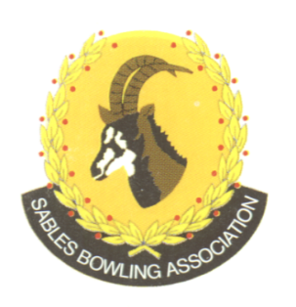
CELL NO: 071 688 3088
E-MAIL:
Sablesbowls1@gmail.com
SABLES BOWLING ASSOCIATION

SABLES DISTRICT STRONGER TOGETHER
Club Memo 23/2026
Memorandum
From
SABLES BOWLING ASSOCIATION
2nd July 2026

TO: CLUB PRESIDENTS
CLUB SECRETARIES

SUBJECT: Bowls SA Team Commonwealth Games 2026 and Gauteng Open

We herewith extend out congratulations to BRIDGET HERSELMAN AND
THABELO MUVHANGO

Who have been selected to represent Team South Africa at the 2026 Glascow Commonwealth Games. Sables would like to wish you all of the best, make us proud.

At the same time, we wish to congratulate our Youth/Junior players for their success in the Gauteng Open

LERATO MPETSI – GOLD
CHARNE VAN STADEN – SILVER
LEILA SNYMAN – SILVER

The district is very proud of you.

Regards

Brian Oxley
Sables President

