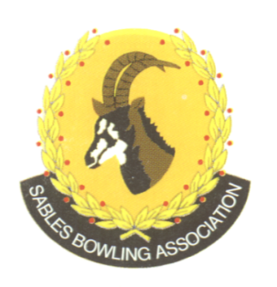
CELL NO: 071 688 3088
E-MAIL:
Sablesbowls1@gmail.com
SABLES BOWLING ASSOCIATION

SABLES DISTRICT STRONGER TOGETHER
Club Memo 22/2026
Memorandum
From
SABLES BOWLING ASSOCIATION
4th JUNE 2026

TO: CLUB PRESIDENTS
CLUB SECRETARIES

SUBJECT: Sables Committees

SABLES EXECUTIVE COMMITTEE
DESIGNATION | NAME | TEL NO | E-MAIL
PRESIDENT | BRIAN OXLEY | 0824530110 | dragonsholme@absamail.co.za
VICE-PRESIDENT | ELYSSES HEINE | 0823888621 | elyssesheine@hotmail.com
SECRETARY | MELANA SELBY | 0834652761 | sablesbowls1@gmail.com
TREASURER | MIKE OLWAGEN | 0833009303 | molwagen@citypower.co.za
EXECUTIVE MEMBER | ANDY SELBY | 0833063184 | andyselby@renoko.co.za
EXECUTIVE MEMBER | FERDI JANSEN | 0713364450 | crusaderstrade2@gmail.com
EXECUTIVE MEMBER | TOMMY SMITH | 0662675883 | tsmith560913@gmail.com
COMPS SECRETARY | SEAN LETLEY | 0723903900 | sean@accutrack.co.za
SABLES TECHNICAL OFFICIALS
DESIGNATION | NAME | TEL NO | E-MAIL
CONVENOR | PIETER DE BEER | 083 651 4008 | topazsteeldesigns@gmail.com
SECRETARY | JOEY JANSEN VAN RENSBURG | 0722568978 | joeyvr6604@gmail.com
MEMBER | DAVE PARKER | 0718766979
MEMBER | SEAN LETLEY | 0723903900 | sean@accutrack.co.za
MEMBER | INGRID CLARK | 0826207326
SABLES DISTRICT COACHES
DESIGNATION | NAME | TEL NO | E-MAIL
CONVENOR | ANDY SELBY | 0833063184 | andyselby@renoko.co.za
SECRETARY
MEMBER | SEAN LETLEY | 0723903900 | sean@mweb.co.za
MEMBER | PIETER DE BEER | 0836514008 | topazsteeldesigns@gmail.com
MEMBER | MAUREEN LOVE | 0849081040 | maureenlove1@gmail.com
MEMBER | JOEY J/V RENSBURG | 0722568978 | joeyvr6604@gmail.com
MEMBER | ANSIE FOURIE | 0637734969 | ansie@dunncorp.co.za
SABLES GREENKEEPERS
DESIGNATION | NAME | TEL NO | E-MAIL
MEMBER | TOMMY SMITH | 0662675883 | tsmith560913@gmail.com
MEMBER | FLIP PRETORIUS | 0827798391 | wbc.watergat@gmail.com

Regards

Brian Oxley
Sables President

