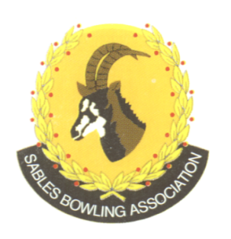
CELL NO: 071 688 3088
E-MAIL:
Sablesbowls1@gmail.com
SABLES BOWLING ASSOCIATION

SABLES DISTRICT STRONGER TOGETHER
Club Memo 21/2026
Memorandum
From
SABLES BOWLING ASSOCIATION
28th May 2026

TO: CLUB PRESIDENTS
CLUB SECRETARIES

SUBJECT: Selected Masters Players

This serves to confirm that Charl Van Staden has withdrawn from the Invitational Masters to be held on 30th & 31st May.

Congratulations to Lerato Mpetsi who has been selected as a replacement.

Regards

Brian Oxley
Sables President

