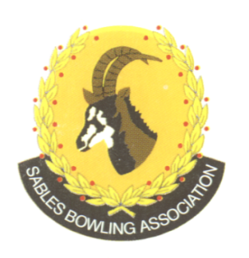
CELL NO: 071 688 3088
E-MAIL:
Sablesbowls1@gmail.com
SABLES BOWLING ASSOCIATION

SABLES DISTRICT STRONGER TOGETHER
Club Memo 20/2026
Memorandum
From
SABLES BOWLING ASSOCIATION
27th May 2026

TO: CLUB PRESIDENTS
CLUB SECRETARIES

SUBJECT: MASTERS MEDALS

Dear All

Please note that all the medals for the Invitational and Veterans Masters will be given out after the Open Masters on the 14th June 2026.

Kind Regards
Elysses Heine
Sables District Vice President

