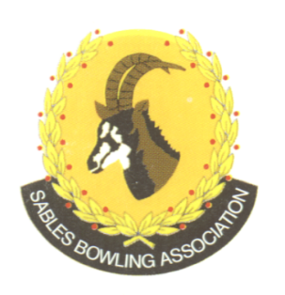
CELL NO: 071 688 3088
E-MAIL:
Sablebowls1@gmail.com
SABLES BOWLING ASSOCIATION

SABLES DISTRICT STRONGER TOGETHER
Club Memo 18/2026
Memorandum
From
SABLES BOWLING ASSOCIATION
19th May 2026

TO: CLUB PRESIDENTS
CLUB SECRETARIES

SUBJECT: Change of venues for hosting of Sables Singles Masters

Dear All

We would like to thank the clubs that have offered up their greens, and all other clubs for their proposals.

Invitational Randfontein Bowling Club
Veterans Discovery Bowling Club
Open Krugersdorp Bowling Club.

Elysses Heine
Sables Vice President

